1.wt is diff between virtualization vs container for cost saving, which one is better

2.where Jenkins hosted in aws?

3.how to manage the creditionals in jenkis?

4.i want to reduce the run time of the Jenkins declarative pipeline?

4.1.What are the benefits of Jenkins shared library??

5.have u written declarative pipeline?

6.how to create a private server in vpc?

7.hiw to create a private subnet and variable in terraform in aws cloud?

8.wt is terraform statefile?if statefile missing wt will be in impact?

9.how to identify the private or public subnet in aws?

10.wt is the docker file? explain?

11.in current project where hosted related docker?

12.wt is command for running container?

13.have u worked on kubernetes?

14.every time pod is restarting ,hw to identify in manifest file,how to resolve it?

15. If I edit container how to update pod automatically?

16.i have database configaration file,,i have creditionals in aws,, where exactly do deploy in container level?

17.how to create persistent volume in k8s?

18.we have 2 namespace,how restrict user access from one to another namespace?

19. wt is cluster role in k8s?

20. wt is RBAC IN K8S?

1.wt is diff between virtualization vs container for cost saving, which one is better

<https://aws.amazon.com/compare/the-difference-between-containers-and-virtual-machines/>

10 app run in 10 vm

10 app container run in single vm ,it is stateless, it is better cost reduce

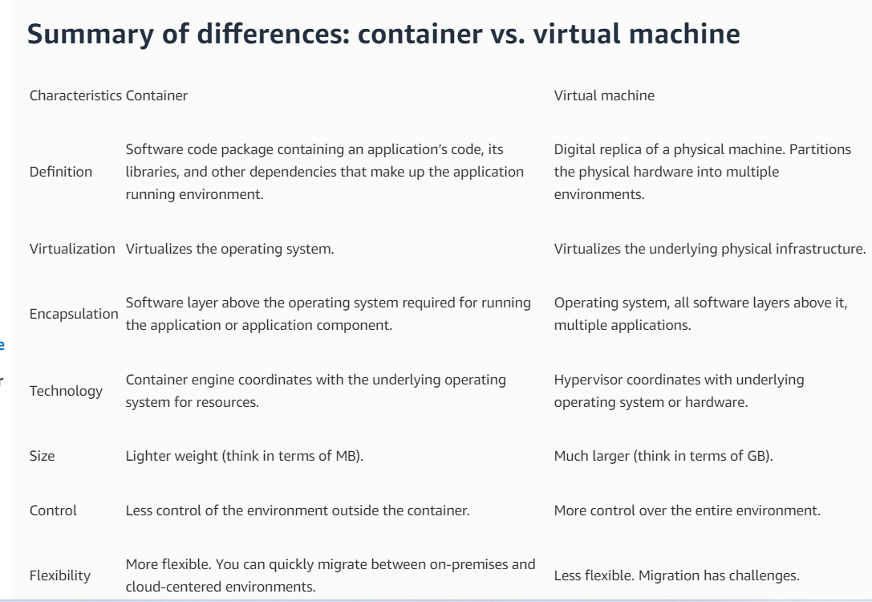

2. .where Jenkins hosted in aws?

Ec2 dashboard

3. how to manage the creditionals in jenkis?

From the Jenkins home page (i.e. the Dashboard of the Jenkins classic UI), click Manage Jenkins > Manage Credentials. Under Stores scoped to Jenkins on the right, click on Jenkins. Under System, click the Global credentials (unrestricted) link to access this default domain. Click Add Credentials on the left.

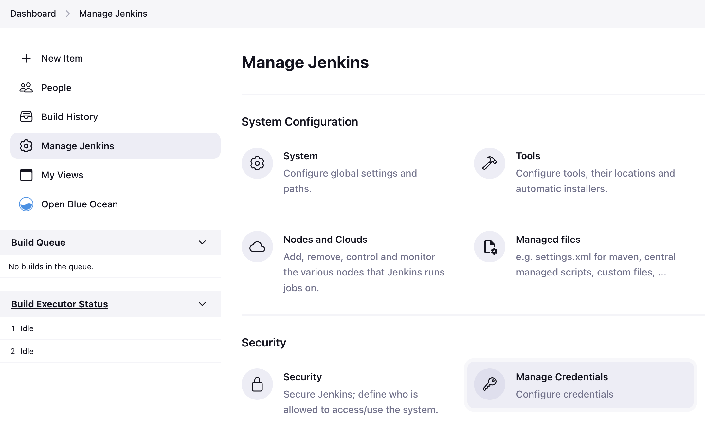

<https://www.jenkins.io/doc/book/using/using-credentials/#:~:text=From%20the%20Jenkins%20home%20page,Add%20Credentials%20on%20the%20left>.

4.i want to reduce the run time of the Jenkins declarative pipeline?

<https://www.linkedin.com/advice/0/how-do-you-optimize-jenkins-performance#:~:text=2%20Configure%20your%20jobs%20wisely,-Designing%20and%20configuring&text=Parallel%20stages%20can%20be%20used,labels%2C%20filters%2C%20and%20priorities>.

5.What are the benefits of Jenkins shared library?

**Benefits**

* Reusability: Shared Libraries allow you to write code once and use it across multiple Jenkins pipelines, reducing duplication and ensuring consistency.
* Maintainability: Centralizing your common scripts and resources in a Shared Library makes it easier to manage and update them as needed.

6. have u written declarative pipeline?

<https://www.jenkins.io/doc/book/pipeline/>

<https://docs.aws.amazon.com/vpc/latest/userguide/vpc-example-private-subnets-nat.html>

7.how to identify the private or public subnet in aws?

<https://dev.to/aws-builders/secure-aws-vpc-using-public-and-private-subnets-4nih>

8. wt is terraform statefile?if statefile missing wt will be in impact??

Loss of State ConfigurationThis happens when the state backend configuration is lost or misconfigured. Terraform cannot access the state file without the correct configuration, rendering resource management impossible.

<https://www.linkedin.com/pulse/recovering-lost-terraform-state-accidental-deletion-corruption-hoang/>

9. how to identify the private or public subnet in aws??

A public subnet is a subnet that is associated with a route table that has a route to an Internet gateway. This connects the VPC to the Internet and to other AWS services. A private subnet is a subnet that is associated with a route table that doesn't have a route to an internet gateway.

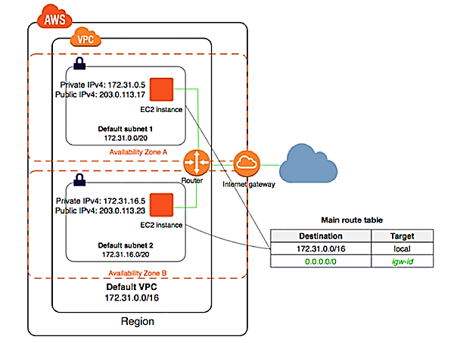

10.wt is the docker file? explain?

<https://www.simplilearn.com/tutorials/docker-tutorial/what-is-dockerfile>

11.in current project where hosted related docker swarm servers?

Ec2 dashboard

12.wt is command for running container?

<https://www.cloudbees.com/blog/the-basics-of-the-docker-run-command>

<https://www.techrepublic.com/article/how-to-run-commands-running-docker/>

13. .have u worked on kubernetes?

Kops of aws

Eks wrk experience in aws

14. every time pod is restarting ,hw to identify in manifest file,how to resolve it?

Or If I edit container how to update pod automatically?

<https://dwdraju.medium.com/a-pod-restarts-so-whats-going-on-fa12bb8a57ea>

<https://gaurav-kaushikgk88.medium.com/self-healing-pods-in-kubernetes-their-restart-policies-84d929778e6d>

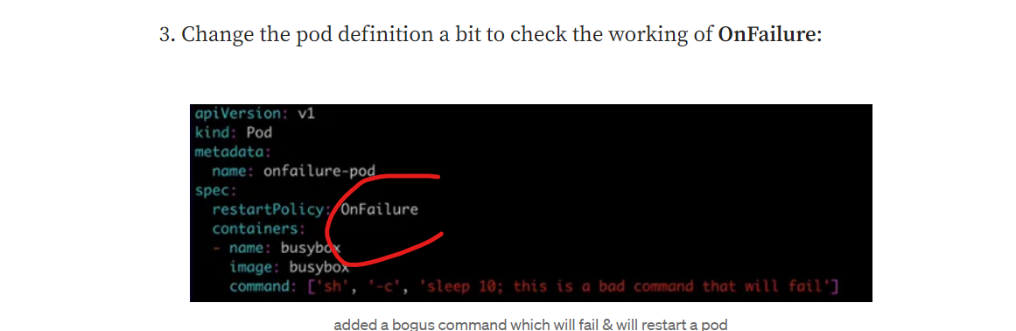

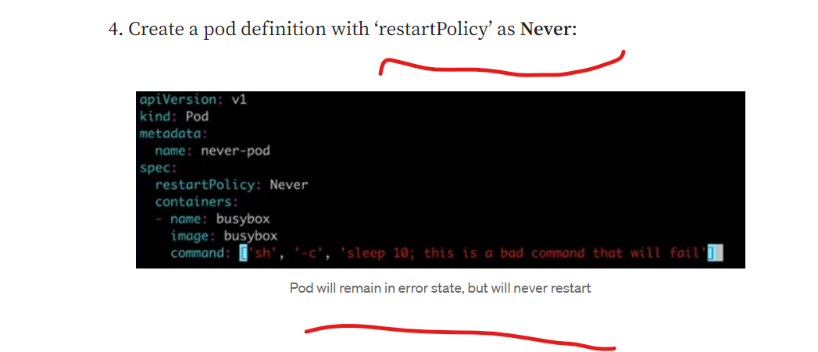

15 have database configaration file,,i have creditionals in aws,, where exactly do deploy in container level?

<https://aws.amazon.com/blogs/compute/securing-credentials-using-aws-secrets-manager-with-aws-fargate/>

16. how to create persistent volume in k8s?

<https://loft.sh/blog/kubernetes-persistent-volumes-examples-and-best-practices/>

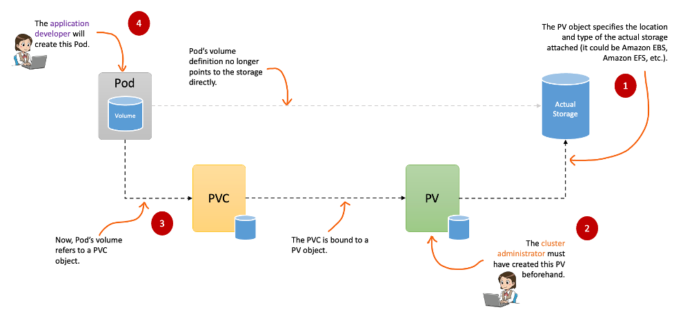

18. we have 2 namespace,how restrict user access from one to another namespace?

<https://stackoverflow.com/questions/63304919/restrict-other-namespace-to-access-pod>

<https://www.middlewareinventory.com/blog/kubernetes-namespace-user/>

<https://www.quora.com/How-can-we-restrict-a-Linux-user-to-a-specific-Kubernetes-namespace>

19 wt is cluster role in k8s?

. In Kubernetes, ClusterRoles and Roles define the actions a user can perform within a cluster or namespace, respectively. You can assign these roles to Kubernetes subjects (users, groups, or service accounts) with role bindings and cluster role bindings.

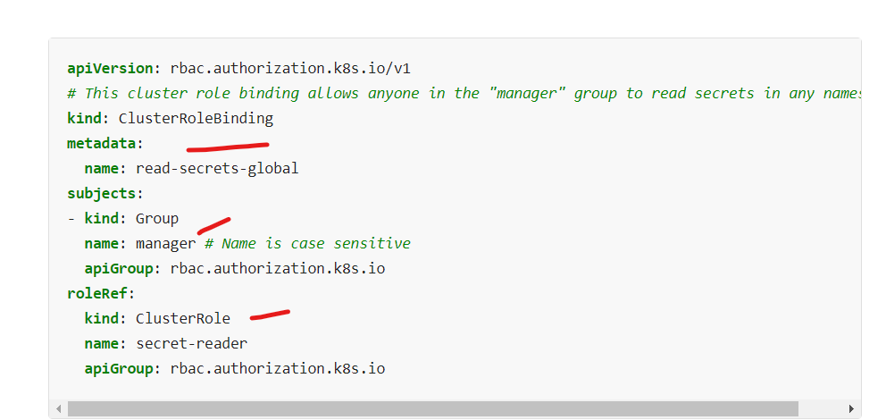

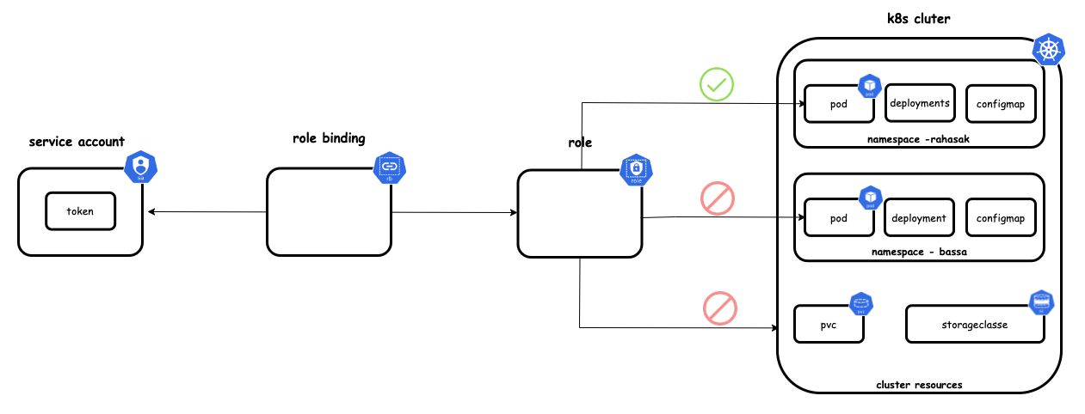s

